**C7083 – DATA VISUALIZATION AND ANALYTICS**

**ID NO: 22302900**

**GitHub link:** <https://github.com/kksam2705/Data-visualization-and-analytics.git>

**Table of contents**

1.Introduction……………………………………………………………………………………………

2.Forest……………………………………………………………………………………………………...

3.Forest area………………………………………………………………………………………………...

4.Brazil forest loss…………………………………………………………………………………………

5.Soybean use………………………………………………………………………………………………

6.Vegetable oil………………………………………………………………………………………………

7.Good graph critic…………………………………………………………………………………………

8.Bad graph critic…………………………………………………………………………………………….

9.Reference……………………………………………………………………………………………………….

**Introduction**

The data sets included in this portfolio comes from the Tidy Tuesday and contain data collected from our world in data. Five datasets are used throughout to create visualizations concerning world deforestation and change in forest area. And we have Brazilian forest loss due to specific factors and soybean and vegetable oil production and usage**.**

**Forest.csv**

Change in Forest area for the year of 1990, 2000, 2010 and 2015 almost all the countries are included.

|  |  |  |
| --- | --- | --- |
| **Variable** | **class** | **Description** |
| entity | character | country |
| code | character | Country code |
| year | double | year |
| Net_forest_conversion | double | Net forest conversion in hectares |

**Forest_area.csv**

Change in global forest area as a percent of global forest area.

|  |  |  |
| --- | --- | --- |
| **Variable** | **Class** | **Description** |
| entity | character | country |
| code | character | Country code |
| year | integer | year |
| Forest_area | double | % of global forest area |

**Brazil_loss.csv**

Loss of Brazilian forest due to specific types.

|  |  |  |
| --- | --- | --- |
| **Variable** | **Class** | **Description** |
| entity | character | country |
| code | character | Country code |
| year | double | year |
| Commercial_crops | double | Commercial crops |
| Flooding_due_to_dams | double | flooding |
| Natural_disturbances | double | Natural disturbances |
| pasture | double | Pasture for livestock |
| Selective_logging | double | Logging for lumber |
| fire | double | Fire loss |
| mining | double | mining |
| Other_infrastructure | double | infrastructure |
| roads | double | Roads |
| Tree_planatations_including_palm | double | Tree planations |
| Small_scale_clearning | double | Small scale clearing |

**Soybean_use.csv**

Soybean production and use by year and country.

|  |  |  |
| --- | --- | --- |
| **Variable** | **Class** | **Description** |
| entity | character | country |
| code | character | Country code |
| year | double | year |
| Human_food | double | Use for human food(tempeh,tofu,etc) |
| Animal-feed | double | Used for animal food |
| processed | double | Processed into vegetable oil,biofuel,processed animal feed |

**Vegetable_oil.csv**

Vegetable oil production by crop type and year.

|  |  |  |
| --- | --- | --- |
| **Variable** | **Class** | **Description** |
| entity | character | country |
| code | character | Country code |
| year | double | year |
| Crop_oil | character | Crop that was used to produce vegetable oil |
| production | double | Oil production in tones |

**Global forest visualization by countries in percentage**

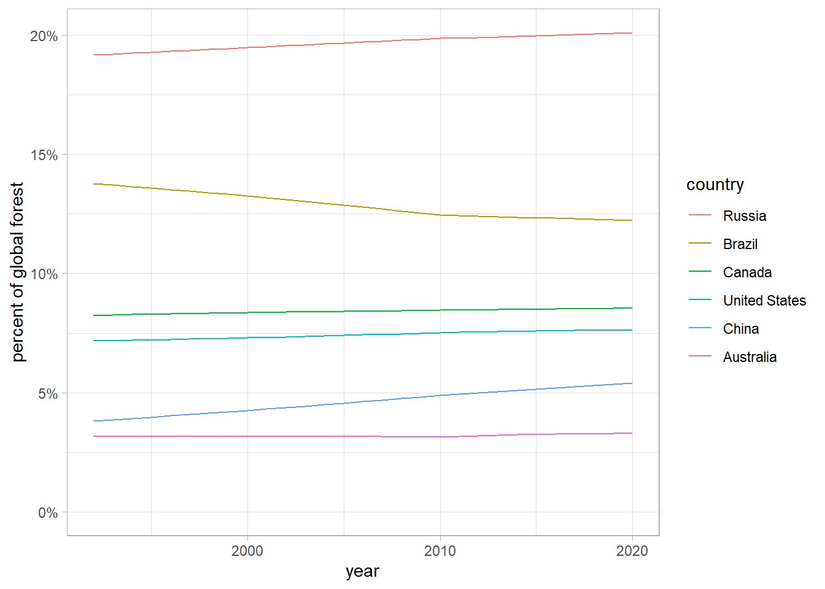

The change in the global forest area in percentage from 1990 to 2020.From the line plot we can clearly say that the forest area of Russia is constantly increasing. Therefore, we can say that Russia is making some big changes to increase the forest area. While for the Brazil its going down its huge loss in forest area for the Brazil. For China and Canada there is a slightly increasing in forest area while list no changes for Australia and United states.

**Global forest conversion in 2015**

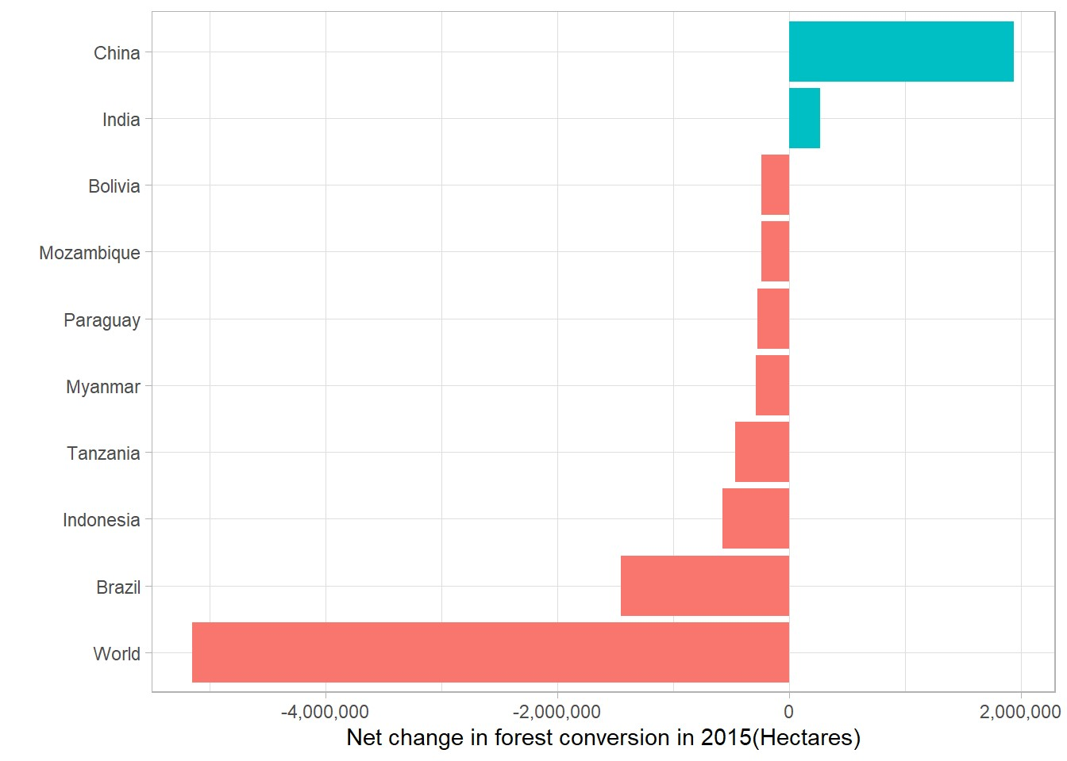

Net change in forest conversion in 2015(Hectares). For China Net Forest conversion is high and India is better as well, but for the world its huge decrease in net forest conversion, followed by Brazil and other countries so on.

**Forest conversion for top 10 countries over the years**

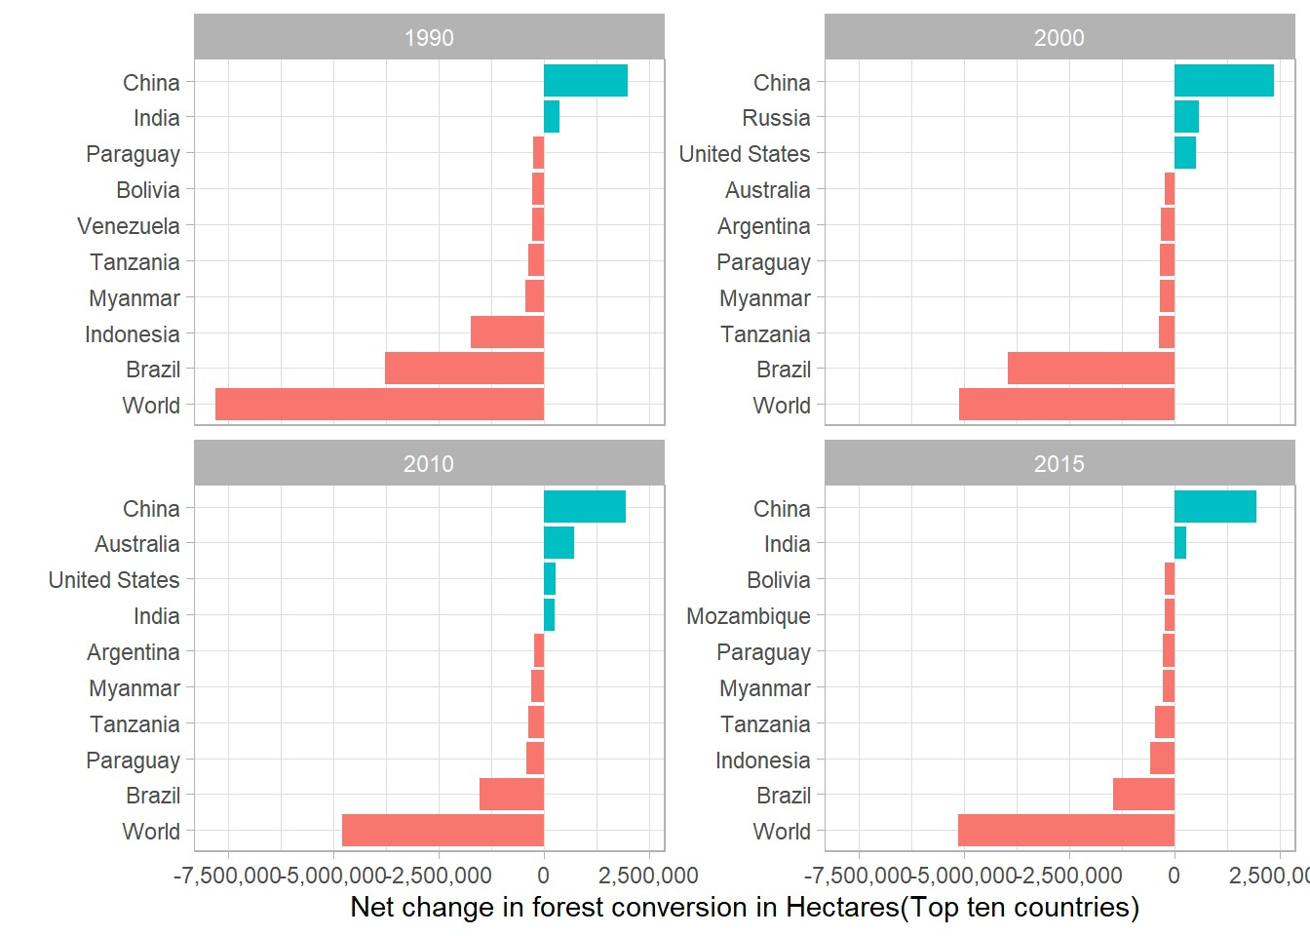

This graph is the best example for the comparison how the Net Forest conversion rate changed over the years. For the world Deforestation is high in 1990 and reduced over the years. But for the Brazil deforestation is high in 1990 and 200 and some good changes in 2010 and 2015.For China the net forest conversion is constant over the years.

**Net Change in forest conversion by line graph**

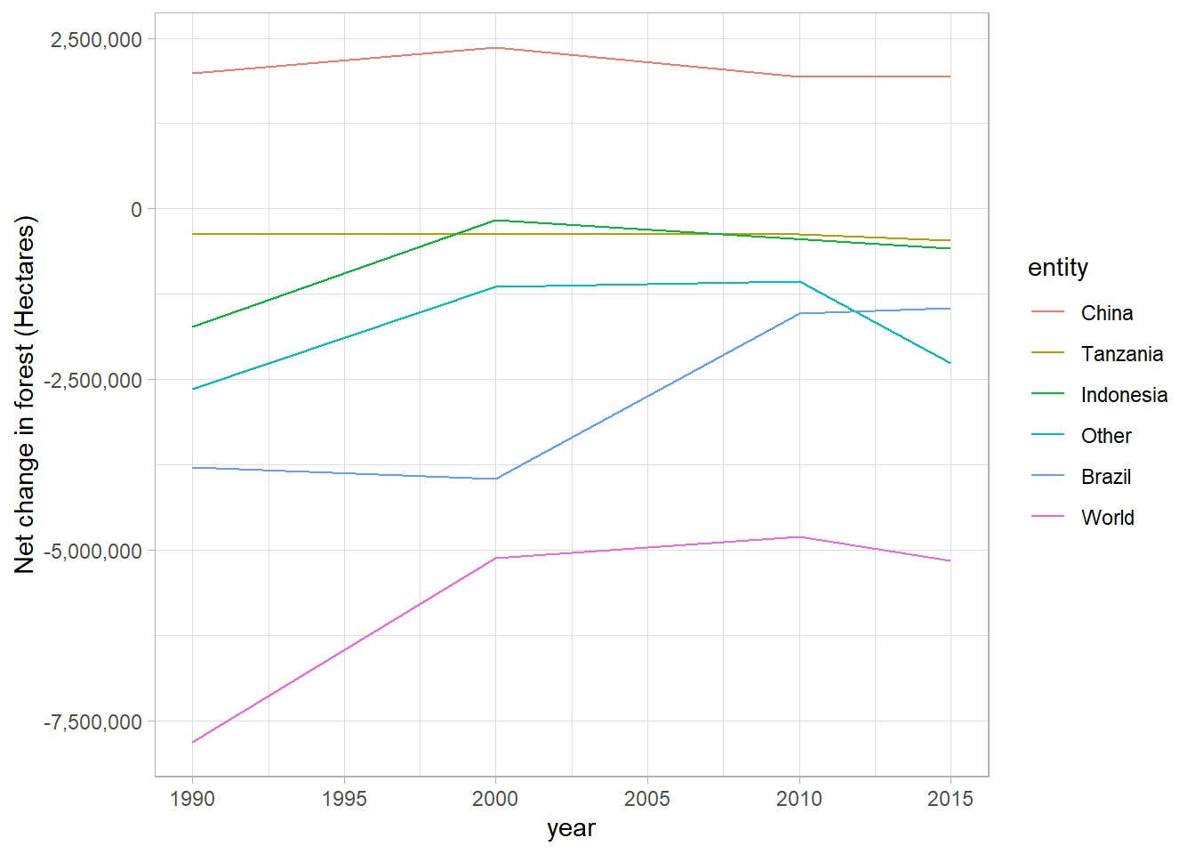

This graph is about net change in forest conversion from 1990 to 2015.Their is a major change in world forst net conversion followed by brazil.indonesia made an impact that moved from negative conversion to positive conversion over the years.china is maintaing the constant position in forest conversion.

**Brazil forest loss in 2013**

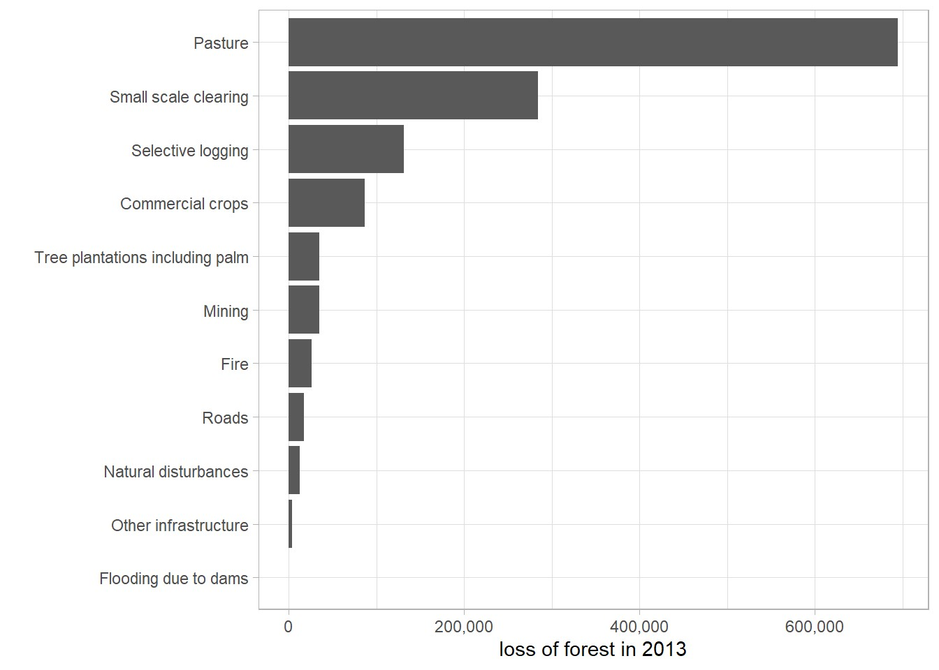

Brazil forest loss due to specific factors in 2013.Pasture is the main cause of Brazil forest loss and followed by small scale clearing, selective logging and so on.

**Brazil forest loss over the years**

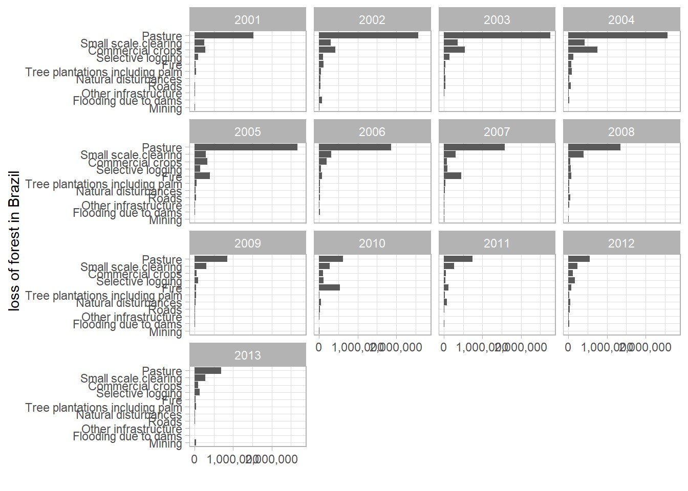

This is the good representation of Brazil forest loss over the years. From this graph we can say that pasture is the main reason for the forest loss. Although in some years it is down, but it is the major factor for forest loss all over the years. And another reason for the major loss is small scale clearing and commercial crops. And other factors like fire, selective lodging and tree plantations including palm.

**Soybean use**

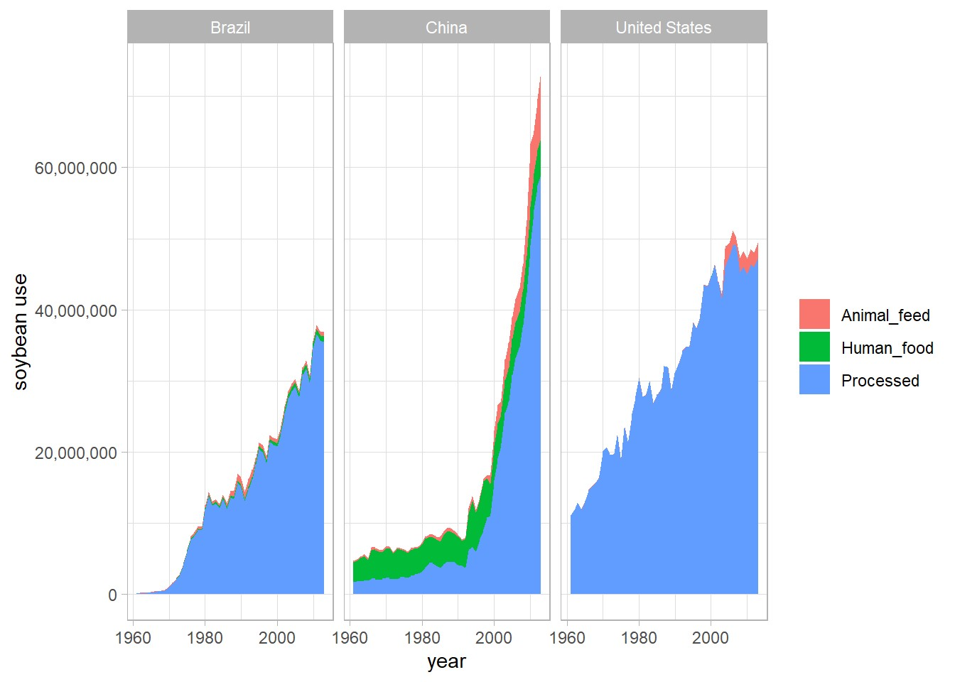

Soybean is mainly is used for processing in united states, China and Brazil. United States is the main consumer of soybean followed by China and Brazil. As a human food China is the main consumer.

**Vegetable oil production**

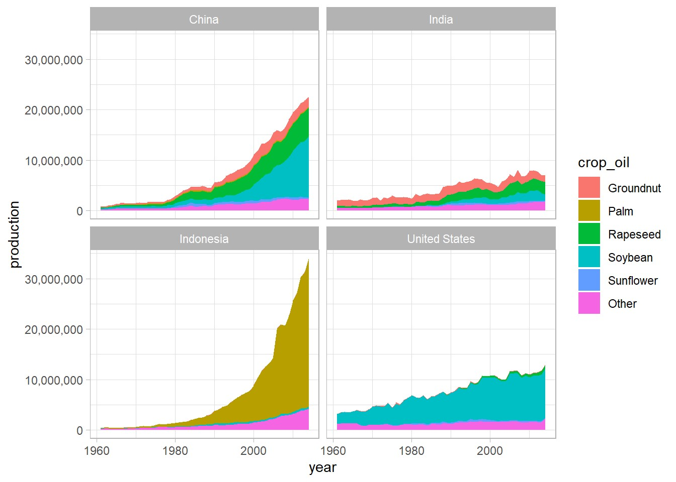China and India are producing more ground nut oil. Indonesia is producing more palm oil. China is producing more rapeseed oil and followed by India. United States produce more soybean oil followed by China. From this graph we can say that China is producing most of the crop oil.

**Good graph critic**

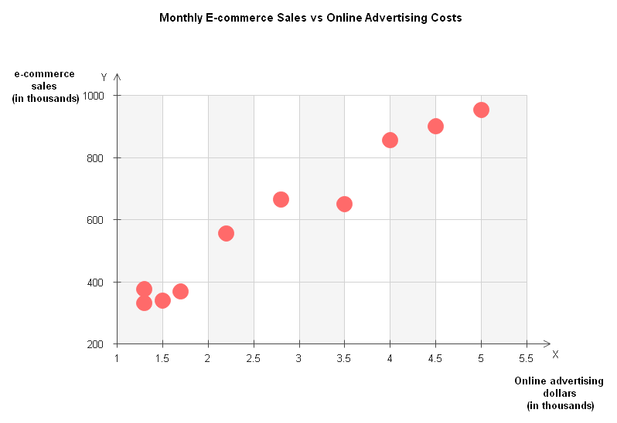

The scatter plot shown above shows how a company's monthly online sales and online advertising expenses relate to one another. You can quickly see how monthly e-commerce sales are impacted by online advertising expenses. E-commerce sales also increase when the price of internet advertising does. Scatter plots can reveal if there are any outlier points or unusual gaps in the data.

**Bad graph critic**

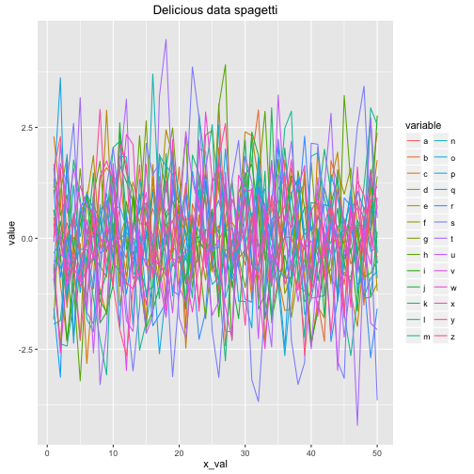

The situation is a mess. You truly have no way of knowing what is happening. You must be able to differentiate between the shades of green for k and I in order to spot any patterns or potential outliers. You must also be able to filter out all the background noise and mentally do 50 comparisons of two variables.

A method called as small multiples can be used to get around this. There are many tiny little charts with just one data element when you divide things up into small multiples. In this instance, there would be 50 distinct line plots, each with one line.

**References**

Interactive Web-Based Data Visualization with R, plotly, and shiny by carson sievert.

<https://ggplot2.tidyverse.org/>

<https://r-graph-gallery.com/ggplot2-package.html>